I have not a phone, so I couldn’t see the details.

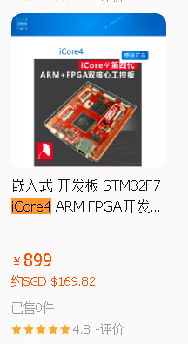  
  
<https://sg.world.taobao.com/item/631572644711.htm?spm=a21wu.10013406.taglist-content.15.3421294aTEmzNZ>